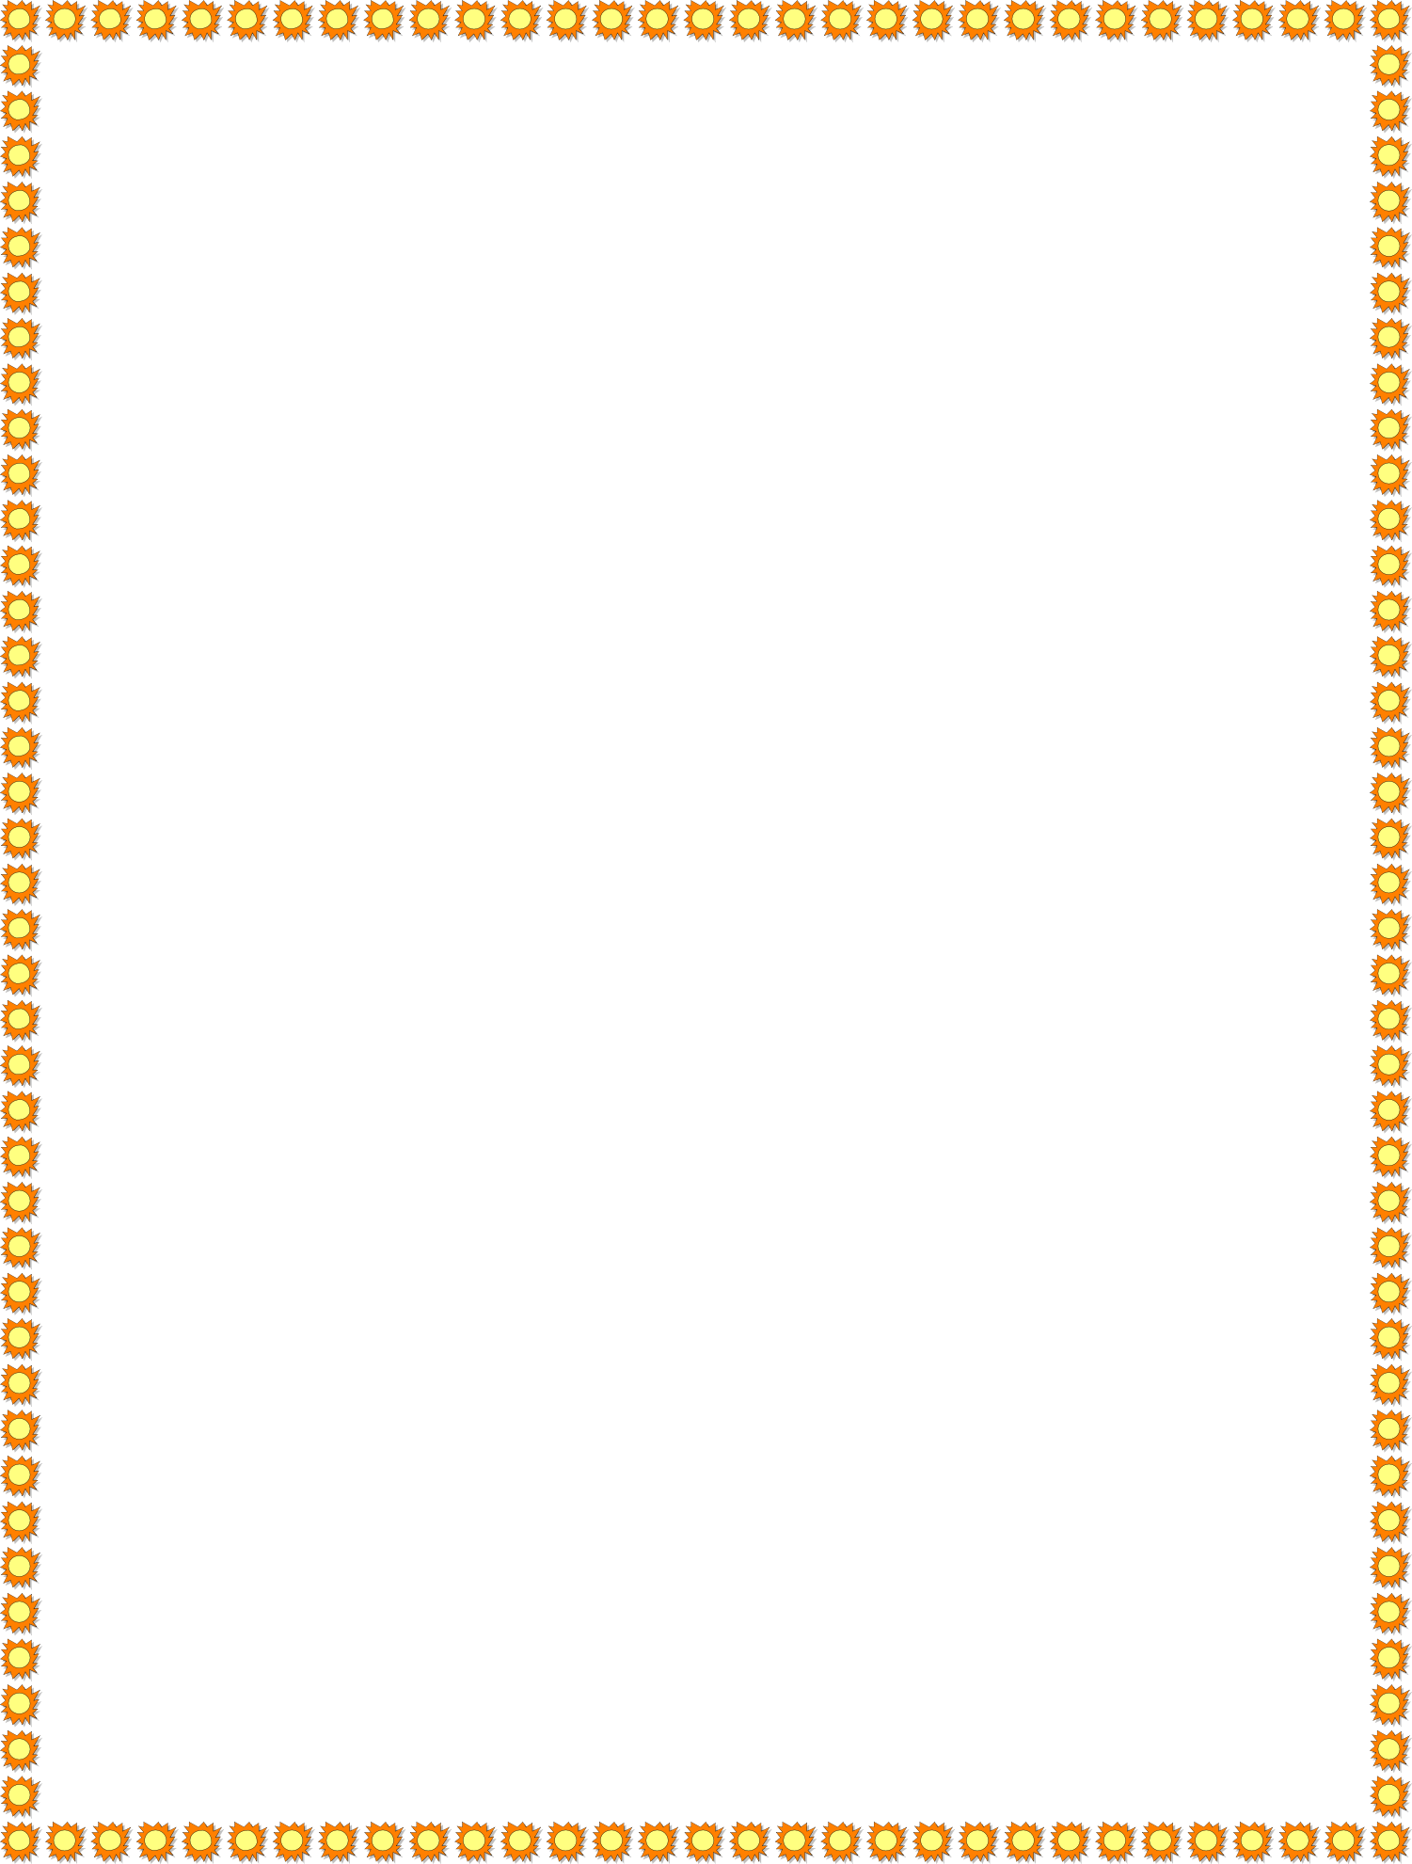2nd Grade Supply List

Bridge Valley Elementary School 2022-2023

* 2 vinyl 2-pocket folders (No Prongs)
* 3 2-pocket folders (1 orange, 1 green, and 1 yellow)
* 1 Pencil case
* 2 Marble Composition Books

* 1 sock/dry eraser
* 1 pair of headphones for iPads (in Ziploc bag with name on it)